IMU Motion Capture Readme
Most of the action editing functions had become legacy functions. The only one active is the IMU motion capture function.

1. Checkout to the IMUWristYX branch.
2. You will need to compile this package with “catkin build”
3. Remember to “source” this workspace.
4. “roscd” to this package’s location, then run the “./XR1_vrep.sh” script. This will launch V-REP with the correct model.
5. Connect your IMU receiver to the machine, make sure its lights are steady, and that you can ping the receiver (usually has the IP:192.168.1.30).
6. Turn on the IMU modules, shake each of them up then leave them idle until they start flashing both green and blue lights.
7. In a new terminal, start the rqt module : ”rqt --standalone vrep_test”.
8. Once the UI is booted up, the receiver should start flashing at a really high frequency, and the IMU modules’ green lights will no longer flash. This means the receiver and the IMU modules are now communicating.
9. Click “startSimulation” or just click “play” on v-rep
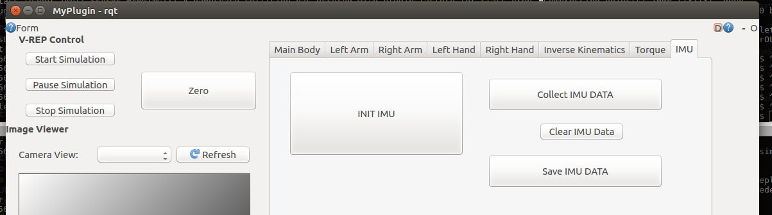
10. The IMU need to be calibrated at least once before it is used. So maintain the pose like XR1 and have someone click “INIT IMU”.
11. The Robot should start moving now.
12. The three buttons on the right all deal with the motion recording. First click “Collect IMU DATA”, the program will start buffering the joint angles.
13. When you are done recording, click “Recoding”. This will pause the recording. You then have two options: clear the buffer or write the buffer to file.
14. “Clear IMU Data” will remove the buffer, if you messed up and need to try again just click this and retry.
15. Click “Save IMU DATA” to write the recorded data. This does not clear the buffer so you will need to click “Clear IMU Data” as well.
16. Click “Recording Paused” to resume the recording.

All codes involving IMU are in “src/IMU_example.cpp”, you can check the specs in there. You can change both the IMU data collecting rate and the joint state collecting rate.
Any data collected from this program needs to be filtered and populated value to reach 200 Hz playback rate before it can be used on XR1.
For example, if the current collecting rate is 33Hz, the interpolation should include 5 data points between the original data points to reach 200Hz.

